

|  |
| --- |
|  |

* 

  



|  |
| --- |
| **Contractual Delivery Date: 30/06/2018**  **Actual Delivery Date: 30/08/2018**  **Type of delivery:  OTHER (Document & Data)**  **Dissemination level:**  **PU** |

|  |
| --- |
| **EXECUTIVE SUMMARY:**  **D2.2 Regions definition & EO database description** |

#### **PREPARATION SLIP**

|  |  |  |  |
| --- | --- | --- | --- |
|  | **Name** | **Organisation** | **Date** |
| **Prepared by** | H. Fournier | MAGELLIUM | 30/062018 |
| **Reviewed by** | R. Ruiloba | MAGELLIUM | 30/06/2018 |
| **Approved for submission by** |  |  |  |

#### **DOCUMENT LOG**

|  |  |  |  |
| --- | --- | --- | --- |
| **Issue** | **Date** | **Comment** | **Author/Organisation** |
| **V1.0** | 30/06/2018 | Initial version | H.Fournier MAGELLIUM |
| **V2.0** | 21/08/2018 | Updated S1 data information | H.Fournier MAGELLIUM |
| **V3.0** |  |  |  |

Figures

**Figure 1 : Current dataset status** 5

Figure 2 : Tiles over Austria 9

Figure 3 : Example of a few Austrian and Estonian tiles 10

Figure 4 : Number of images per tile 11

Figure 5 : Cloud coverage the 3 countries from L1C cloud mask from 2016 to 2017 (blue = 0% of clouds, red=100%) 12

Figure 6 : Cloud map on Austria and Slovenia using s2cloudless algorithm (blue = 0% of clouds, red = 100%) 12

Figure 7 : Cloud map on Denmark using s2cloudless algorithm (blue = 0%, red = 100%) 13

Figure 8 : Cloudiness in Europe produced by GeoVille 13

Figure 9 : Manually labelled tile (red = clouds) 14

Figure 10 : L1C cloud mask on Scene1 (red = clouds) 15

Figure 11 : Scene 2 16

Figure 12 : L1C cloud mask on Scene 2 (red = clouds) 17

Figure 13 : MACCS diagram 18

Figure 14 : Result on scene 1 (red = clouds) 19

Figure 15: Sen2Cor cloud mask on scene 1 (red = clouds) 20

Figure 16 : s2cloudless cloud mask 21

Figure 17 : Measures on the cloud masks tested 22

Figure 18 : Example of winter season for some tiles 22

Figure 19 : Let-it-snow snow mask on scene 1 (blue = snow) 23

Figure 20 : Sen2Cor snow mask (blue = snow) 24

Figure 21 : Original L1C data (scene 1) 25

Figure 22 : MAJA L2A data produced 26

Figure 23 : Sen2Cor L2A Data produced 27

Figure 24 All LPIS data in Austria 28

Figure 25 : Ratio of pixel inside the Austrian LPIS data (any crop) in a few tiles 29

Figure 26 : Example on the tile T33TXN 29

Figure 27 : Example on the tile T33UUP 30

Figure 28 : Example on the tile T33UVP 30

Figure 29: Example on the tile T33TUN 31

Table of Contents

Figures 3

Table of Contents 4

1 Introduction 5

2 Localization and TIME PERIOD 5

3 Data AVAILABLE 5

3.1 Sentinel-1 Data 6

3.1.1 Sentinel-1 pre-processing operations 6

3.2 Sentinel-2 DATA 9

3.3 Cloud coverage 11

4 Clouds 13

4.1 Level 1C cloud mask 15

4.2 MAJA/MACCS 18

4.3 Let-it-snow 19

4.4 FMASK 19

4.5 L2A MAsks - Sen2Cor 20

4.6 S2cloudless 21

4.7 Performance comparison 22

5 Snow detection 22

6 L2A Correction 25

4.8 MAJA / MACCS 25

4.9 Sen2COR 27

7 LPIS analYsis 28

# Introduction

This document presents the Earth observation dataset that will be used in the Perceptive Sentinel project for testing and demonstrate algorithms capabilities (mostly in the deep learning part) and how they were selected. Some statistics and graphics are also computed in order to have a first data quality analysis and allow a better use of the dataset.

# Localization and TIME PERIOD

The study will first take place in 3 countries: Austria, Slovenia and Denmark. The regions and time period selection is guided by the availability of non-EO data necessary for machine learning algorithms and validation tasks. Thus, the project will have access to non-Earth-Observation data in those areas (soil type, crop type…) that will be used to train deep learning models and validate feature extraction algorithms and added-value products.

The EO dataset is composed by Sentinel-1 and Sentinel-2 data in the time period 2016-2017 (2016-01-01 to 2017-12-31). Sentinel-3 data would be added to the dataset later in the project.

In next sections, we provide an analysis of the data available and suitable for time series analysis, feature extraction and training in terms of acquisitions number and percentage of cloud free images and pixels. This information is useful for deep learning algorithms which need a large number of samples for training.

Nevertheless, the cloudy regions are not excluded from the analysis tools; rather, a solution has to be found for cloudy regions in order to provide added-value production all the regions at any weather conditions. Sentinel-1 data provide an alternative to optical (Sentinel-2) data in cloudy conditions.

# Data AVAILABLE

We describe here how we chose the data and how they are organised in the dataset. The analysis is done for Sentinel-1 and Sentinel-2 acquisitions.

As said the EO dataset is composed by Sentinel-1 and Sentinel-2 data in the time period 2016-2017 (2016-01-01 to 2017-12-31). Sentinel-3 data would be added to the dataset later in the project.

The data are available in the project ftp.

The dataset is currently composed of:

|  |  |  |  |  |  |
| --- | --- | --- | --- | --- | --- |
|  | S2A-L1C | S2B-L1C | S2A-L2A | S2B-L2A | S1 |
| Austria | ✓ | ✓ | ✓ | ✓ | ✓ |
| Slovenia | ✓ | ✓ | ✓ | ✓ | ✓ |
| Denmark | ✓ | ✓ | ✓ | ✓ | ✓ |

**Figure 1 : Current dataset status**

## Sentinel-1 Data

S-1 data is provided by the ESA ground segment via the Copernicus Sentinel data hub at the data level described in section 2.1 of the [ATBD](https://www.dropbox.com/home/PerceptiveSentinel-temporary/WP/WP3/Drafts?preview=ATBD_MAG-21-04-2018.docx) document (D 3.1 Algorithm theoretic baseline document). Following their acquisition, SAR images require geometric and radiometric calibration along with speckle noise filtering steps that can be performed using available open source processing tools presented in the following sections.

According to the specific data processing purpose, the pre-processing steps can be sequenced differently. However, pre-processing of SAR images generally follows a three steps approach:

* **Correction of geometric distortions** due to the curvature and rotation of the earth, the sensors angles and perspective or the terrain relief.
* **Removal of sensor or atmospheric 'noise'** due to the sun's azimuth, elevation and atmospheric conditions that can influence the observed energy.
* **Removal of speckle noise** caused by the coherent nature of back-scattered waves from multiple distributed targets.

The Sentinel-1 Toolbox ([S1TBX](https://sentinel.esa.int/web/sentinel/toolboxes/sentinel-1)) consists of a collection of processing tools, data product readers and writers and a display and analysis application to support the large archive of data from ESA SAR missions including SENTINEL-1. The various processing tools could be run independently from the command-line and also integrated within the graphical user interface.

The Toolbox includes tools for calibration, speckle filtering, coregistration, orthorectification, mosaicking, data conversion, polarimetry and interferometry.

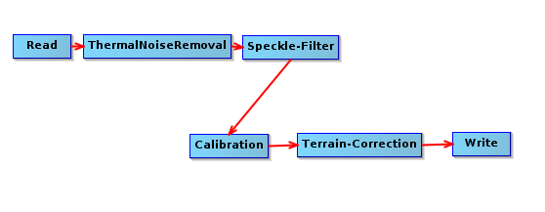

Figure 2 : Graph of selected pre-processing operations

### Sentinel-1 pre-processing operations

We want to use both Sentinel-1 and Sentinel-2, so we need to be able to overlay images from both sources with precision. However Sentinel-1 data from the ESA ground segment is not orthorectified and some operations are necessary:

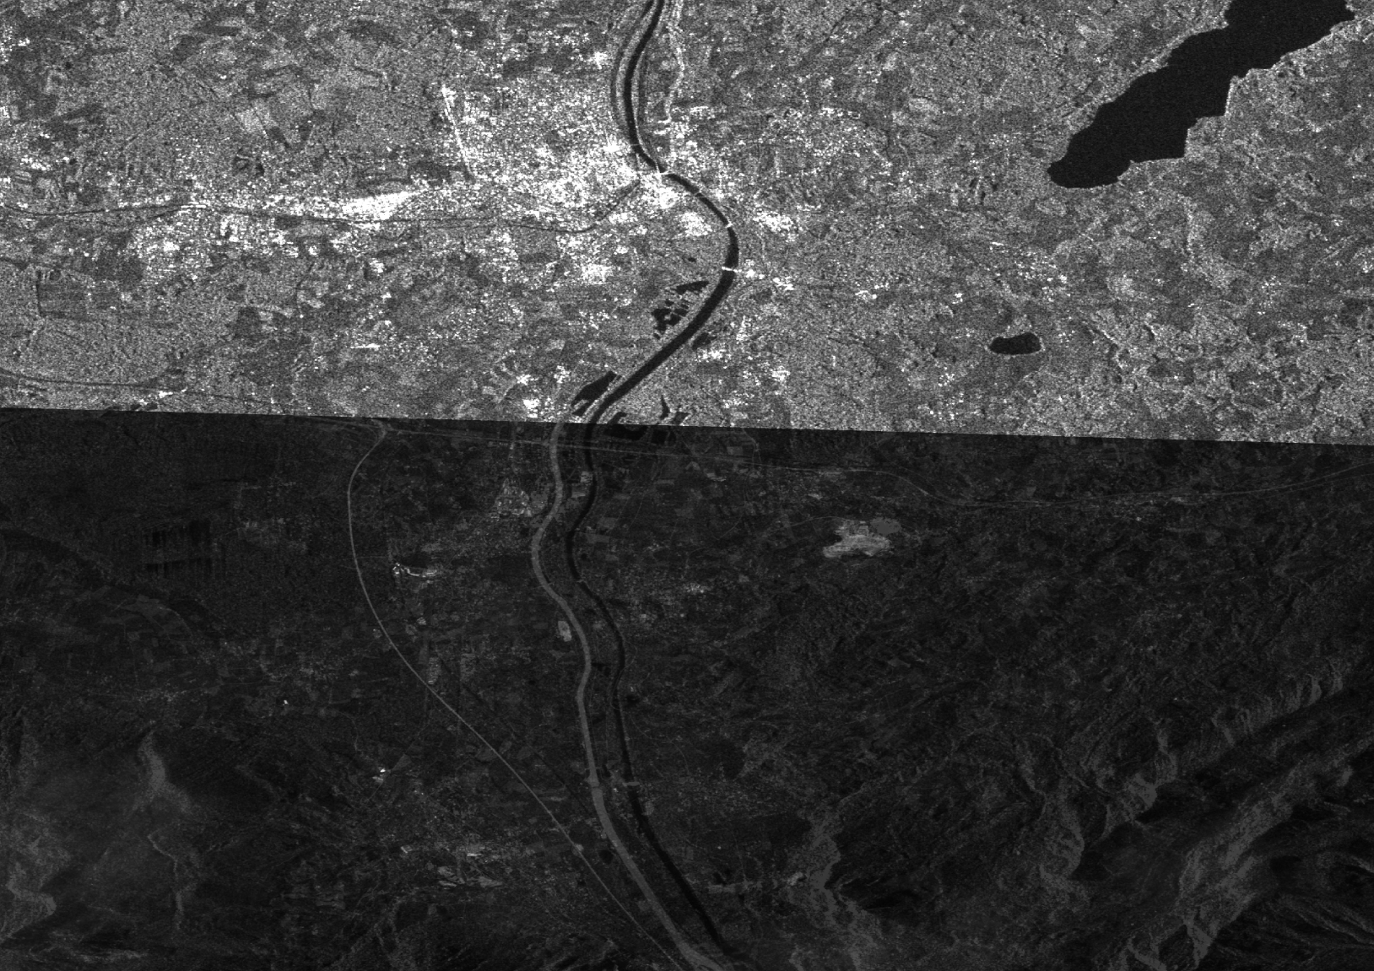

Figure 3 : Overlay of a Sentinel-2 band (bottom part) and a Sentinel-1 band without correction

**ThermalNoiseRemoval:**

Thermal noise correction can be applied to Sentinel-1 Level-1 SLC products as well as Level-1 GRD products which have not already been corrected. The operator can also remove this correction based on the product annotations (i.e. to re-introduce the noise signal that was removed). Product annotations will be updated accordingly to allow for re-application of the correction.

**Speckle-Filter:**

SAR images are affected by speckle noise that inherently exists in and which degrades the image quality resulting in salt and pepper noise throughout the image. It is caused by the coherent nature of back-scattered waves from multiple distributed targets. It is locally strong and it increases the mean grey level of a local area. Reducing the speckle noise enhances radiometric resolution but tends to decrease the spatial resolution.

**Calibration:**

The corrections that get applied during calibration are mission-specific. Therefore the software will automatically determine what kind of input product is set and what corrections need to be applied based on the product’s metadata. For converting digital pixel values to radiometrically calibrated backscatter, all the required information can be found in the product. A calibration vector is included as an annotation in the product, allowing simple conversion of image intensity values into sigma or gamma values.

The objective of SAR calibration is to provide imagery in which the pixel values can be directly related to the radar backscatter of the scene. To do this, the application *output scaling* applied by the processor must be undone and the desired scaling must be applied. Level-1 products provide four calibrations Look Up Tables (LUTs) to return to the Digital Number (DN). The LUTs apply a range-dependent gain including the absolute calibration constant. For GRD products, a constant offset is also applied.

**Terrain-correction:**

The Range Doppler Terrain Correction Operator implements the Range Doppler orthorectification method for geocoding SAR images from single 2D raster radar geometry. It uses available orbit state vector information in the metadata or external precise orbit (only for ERS and ASAR), the radar timing annotations, the slant to ground range conversion parameters together with the reference DEM data to derive the precise geolocation information.

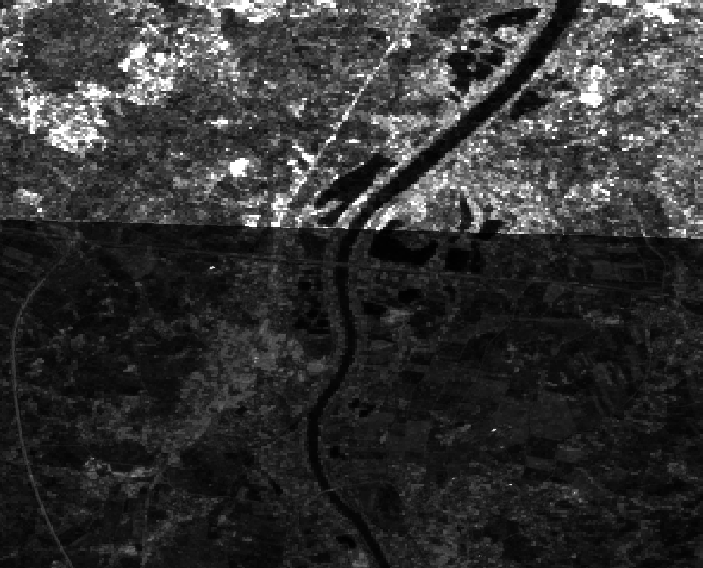

Figure 4 : Overlay of a Sentinel-2 band (bottom part) and a corrected Sentinel-1 band

The corrected images are then cut and organized in the same way as Sentinel-2 images (UTM/WGS84 projection). It takes about 5min per raw image to correct it and cut it in the right format.

All those operations are made thanks to a few python scripts:

* sentinel_api.py : Produce the script that download all Sentinel-1 inside a region defined by a shapefile
* unzip.py : Unzip all the downloaded files
* batch_s1_process.py : Correct all images (see above)
* S1_process.py : Cut all Sentinel-1 images into Sentinel-2 tiles

The raw downloaded Sentinel-1 data represent about 4.5To for 2500 images.

Once corrected, cut and correctly organized, the Sentinel-1 dataset takes about 600Go.

## Sentinel-2 DATA

This section presents the statistics about the number of Sentinel-2 acquisitions available in the targeted regions for 2016 and 2017. We will use the Sentinel-2 L1C tiles convention to split the areas.

All the tiles which the footprint covers a part of the country, even small, are included in the dataset. The goal is to ensure a maximum coverage, even if some zones are acquired twice. Here after, an example, over Austria, is provided as a reference of the tile selection process.



**Austria**

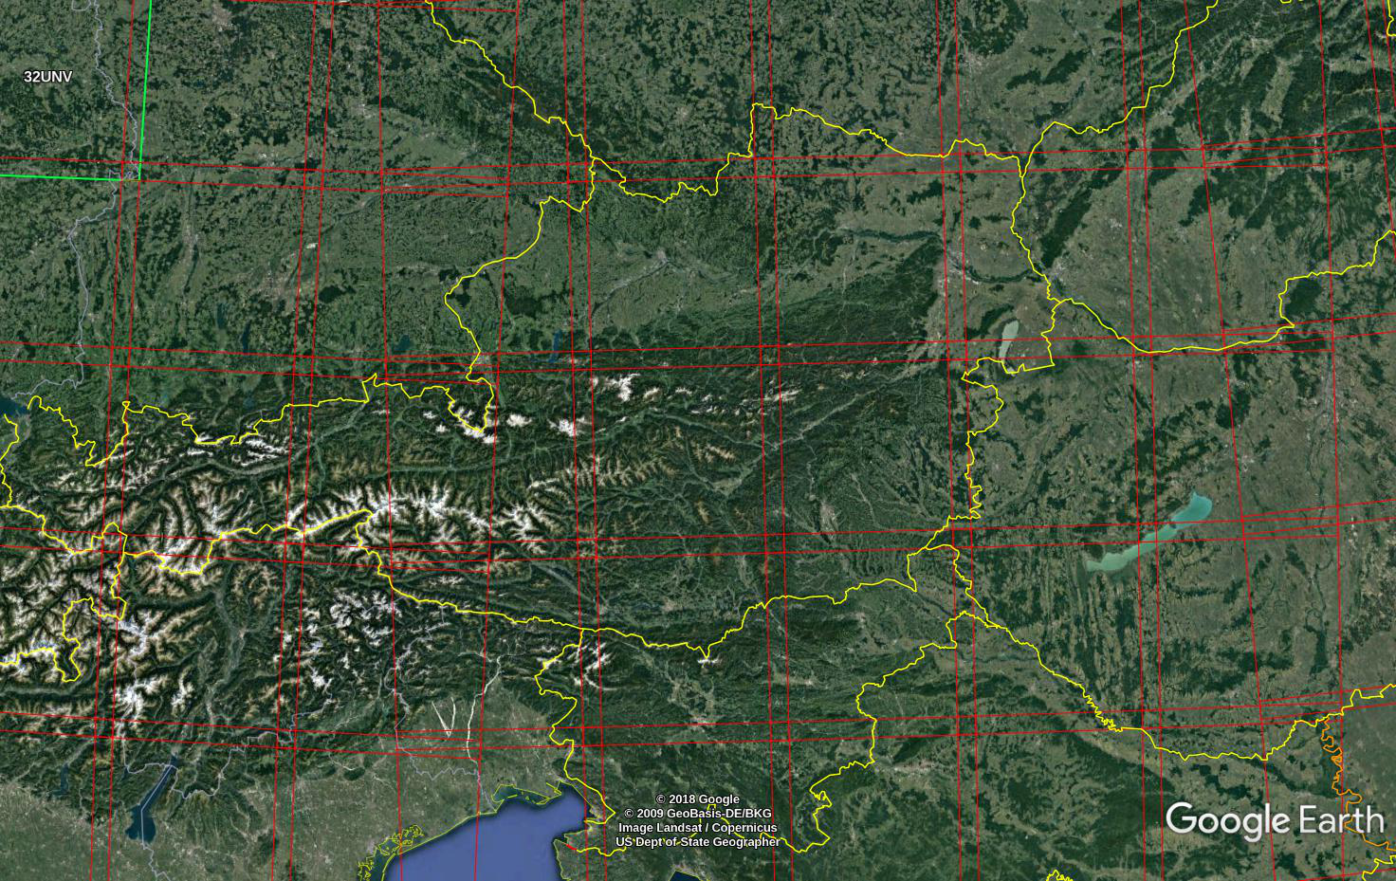

Figure 5 : Tiles over Austria

T

|  |  |  |  |
| --- | --- | --- | --- |
| **ID Tiles** | **Approximated center** | | **Notes** |
| 32TNS | Lat | 46°32’ | Small area in Austria |
| Long | 9°44’ |
| 32TNT | Lat | 47°19’ | Small area in Austria |
| Long | 9°41’ |
| 32TPS | Lat | 46°26’ | Small area in Austria |
| Long | 10°56’ |
| 32TPT | Lat | 47°17’ | About half of the area in Austria |
| Long | 11°3’ |
| 32TQS | Lat | 46°29’ | Small area in Austria |
| Long | 12°7’ |
| 32TQT | Lat | 47°20’ |  |
| Long | 12°7’ |
| 33TUM | Lat | 46°26’ | ~Half in Austria |
| Long | 12°56’ |
| 33TUN | Lat | 47°18’ |  |
| Long | 12°56’ |
| 33TVM | Lat | 46°28’ | ~Half in Austria |
| Long | 14°25’ |
| 33TVN | Lat | 47°20’ |  |
| Long | 14°22’ |
| 33TWM | Lat | 46°27’ | Small area in Austria |
| Long | 15°41’ |
| 33TWN | Lat | 47°20’ |  |
| Long | 15°43’ |
| 33TXN | Lat | 46°17’ | Small area in Austria |
| Long | 16°56’ |
| 33UUP | Lat | 48°11’ | ~Half in Austria |
| Long | 13°14’ |
| 33UVP | Lat | 48°12’ |  |
| Long | 14°21’ |

Figure 6 : Example of a few Austrian and Estonian tiles

A script was written to download and format the available L1C data from Sentinel-2:

usage: download_s2_tiles.py [-h] [-o output_dir] [-nt number_threads]

tile_file begin_date end_date

Download multiple Sentinel 2 tiles over any period.

positional arguments:

tile_file File containing the list of tiles to download

begin_date Begin date

end_date End date

optional arguments:

-h, --help show this help message and exit

-o output_dir Output directory

-nt number_threads Number of threads used to download (default to 1)

Read from the tiles_file which tiles to download

The file containing the list of tiles to download must also provide the approximate coordinate of the center of each tile for the script to work. (Lines starting with ‘#’ are ignored, 1 entry per line).

# Austria :

#T32TNS 46.5 9.7

#T32TNT 47.3 9.7

#T32TPS 46.4 10.9

#T32TPT 47.3 11.5

#T32TQS 46.5 12.1

#T32TQT 47.3 12.1

T33TUM 46.5 12.9

T33TUN 47.3 12.9

T33TVM 46.5 14.4

T33TVN 47.3 14.3

The 3 countries span over 40 tiles with about 40 acquisitions per tile and per year.

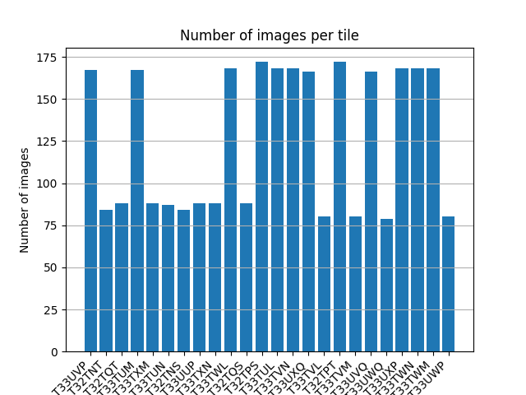

Figure 7 : Number of images per tile

The Sentinel-2 raw dataset for the 3 countries from 2016-01-01 to 2017-12-31 represents around 6.4To. But only a small part of these images can be used to train a deep learning model. We need, in fact, to have corresponding LPIS data and clean (cloud free) images. That is why we need to eliminate every part of those images that cannot be used for training such as cloud or snow covered areas.

## Cloud coverage

Some acquisition cannot be used for training or information extraction because of the clouds present on the images. Some areas/countries are more often cloudy than others.

In order to visualise the areas that will provide lower information for learning or time series analysis, we proceeded to build a cloud coverage map from cloud detection algorithm (see section 4).:

Next image shows a cloud coverage map on Austria using Sentinel-2 level 1C cloud masks (cf. section 4.1):

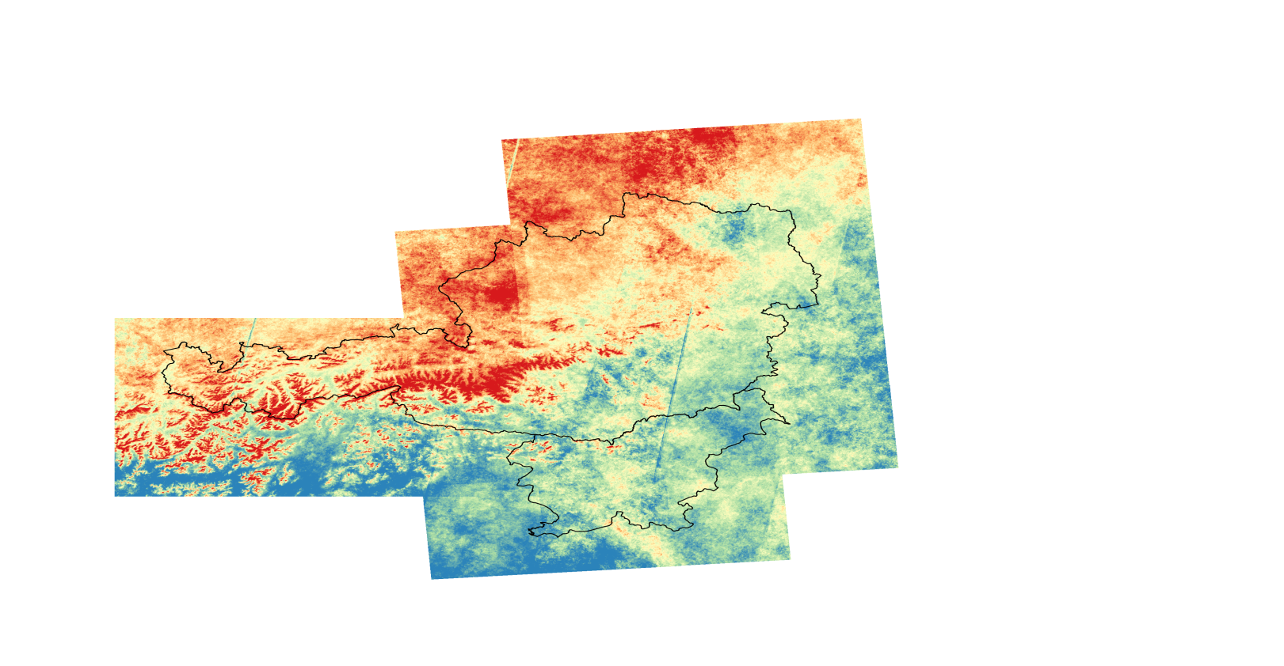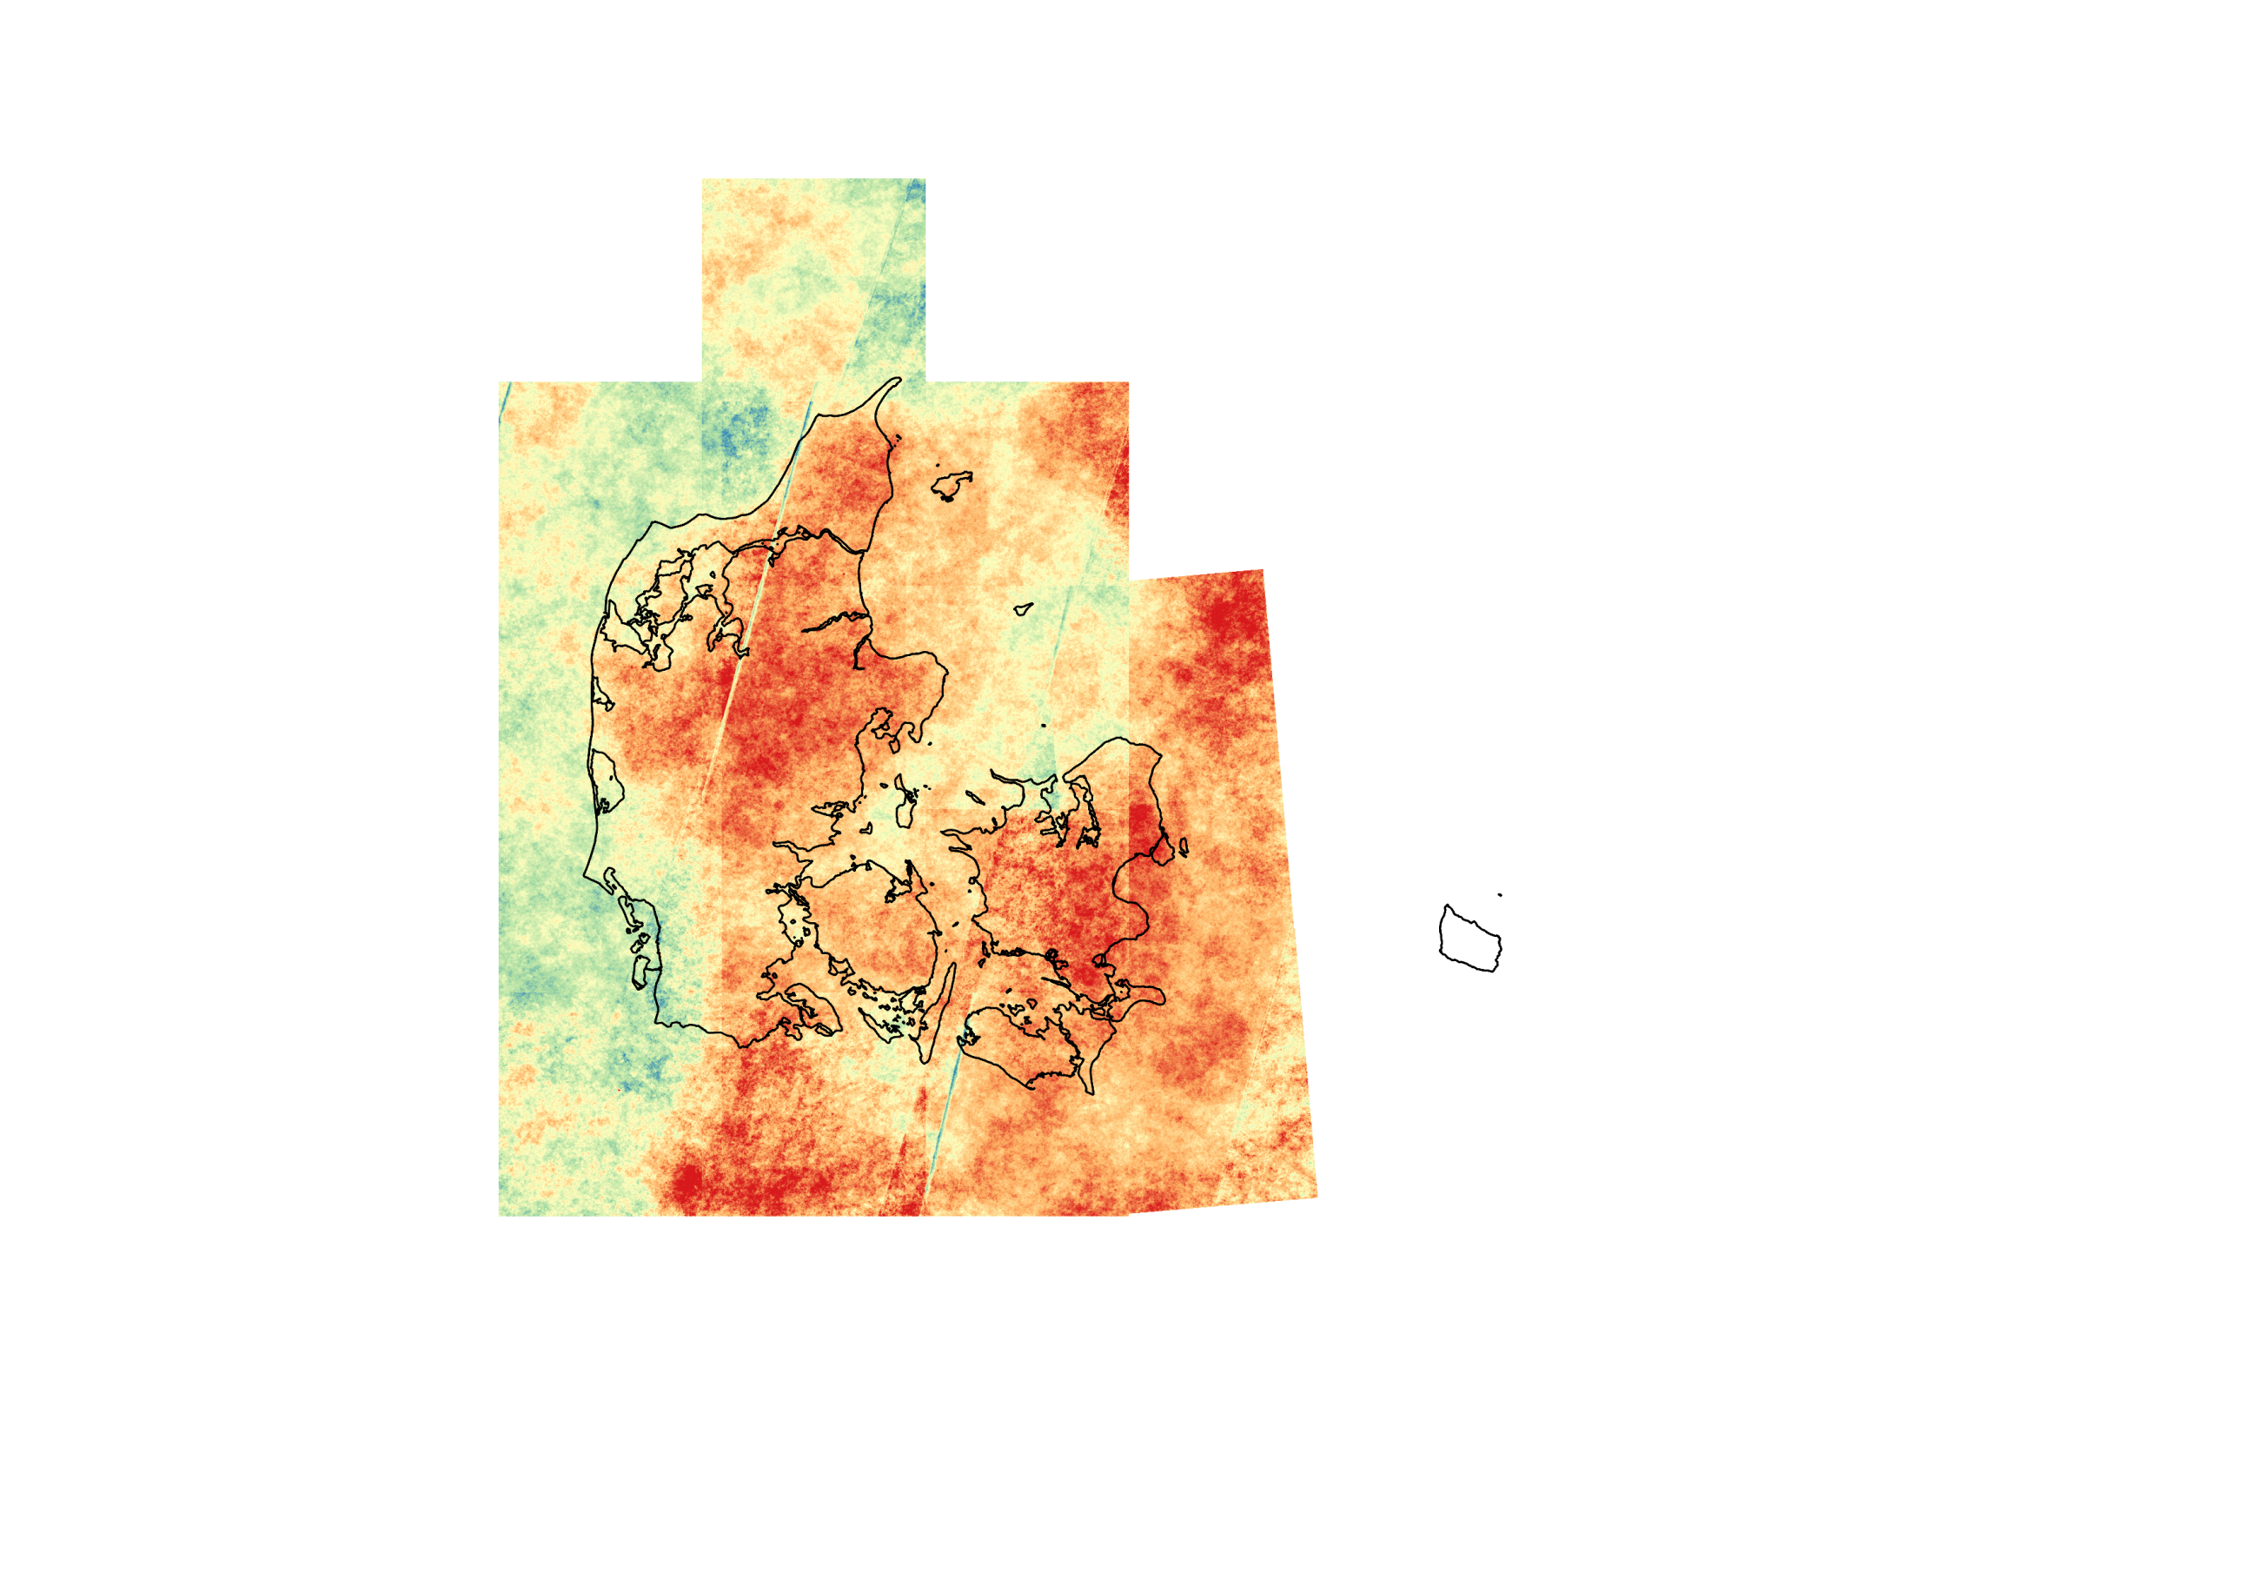

Figure 8 : Cloud coverage the 3 countries from L1C cloud mask from 2016 to 2017 (blue = 0% of clouds, red=100%)

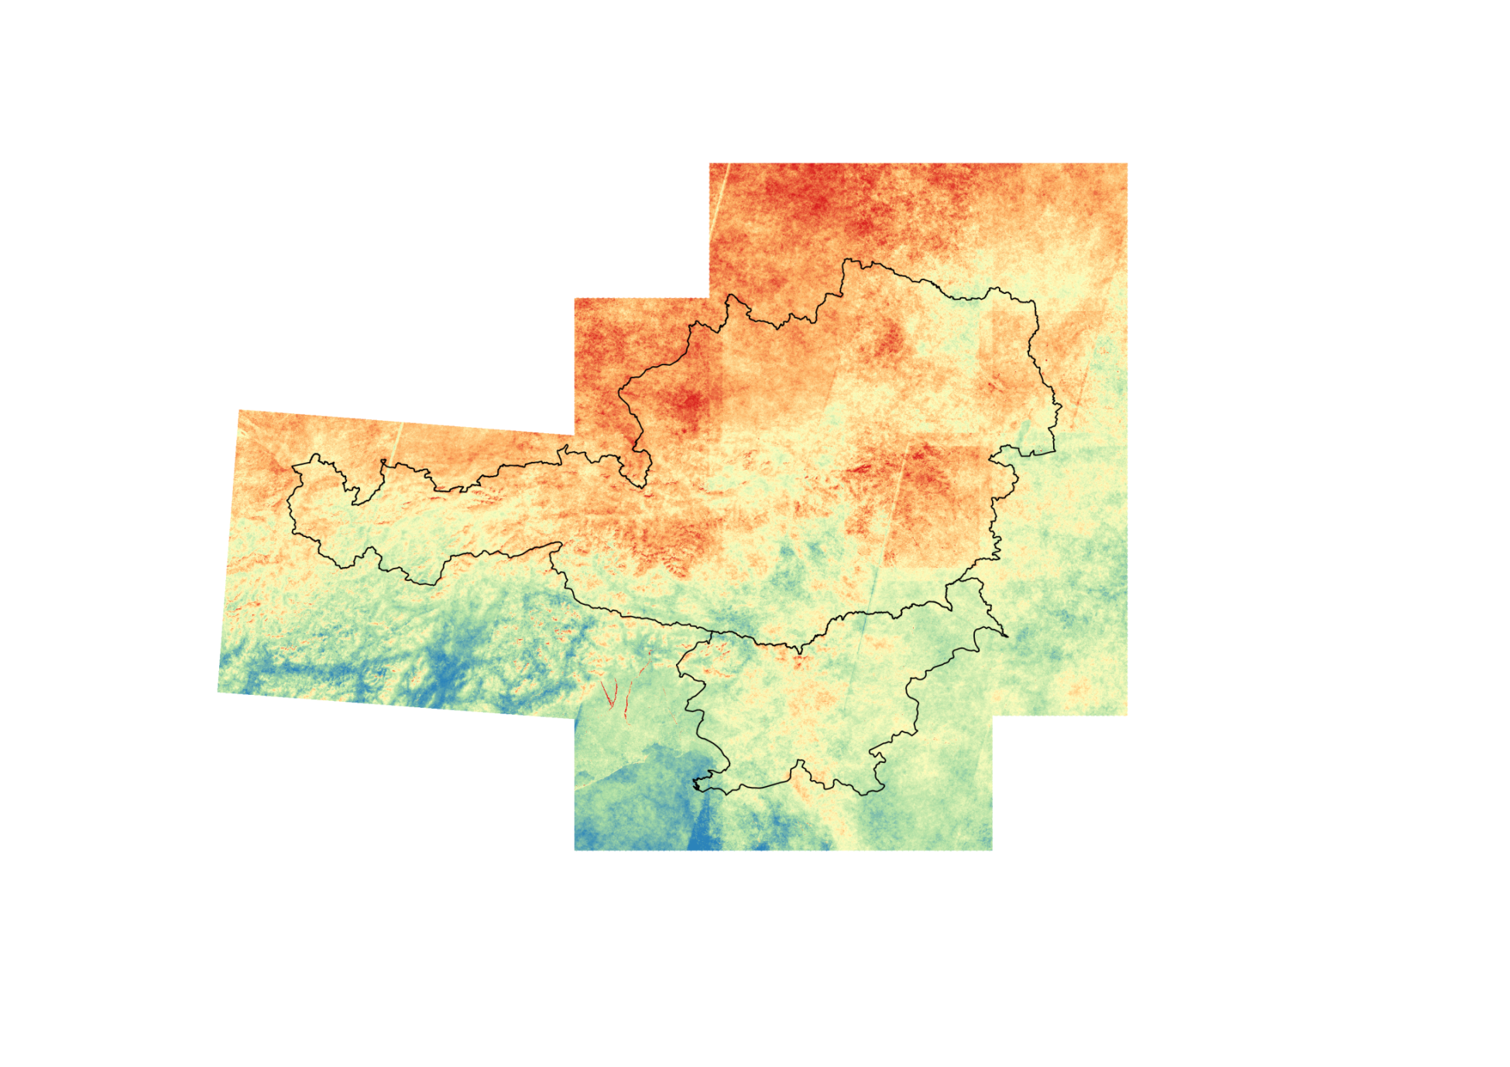A more precise cloud mask is obtained with the s2cloudless (cf. section 4.6):

Figure 9 : Cloud map on Austria and Slovenia using s2cloudless algorithm (blue = 0% of clouds, red = 100%)

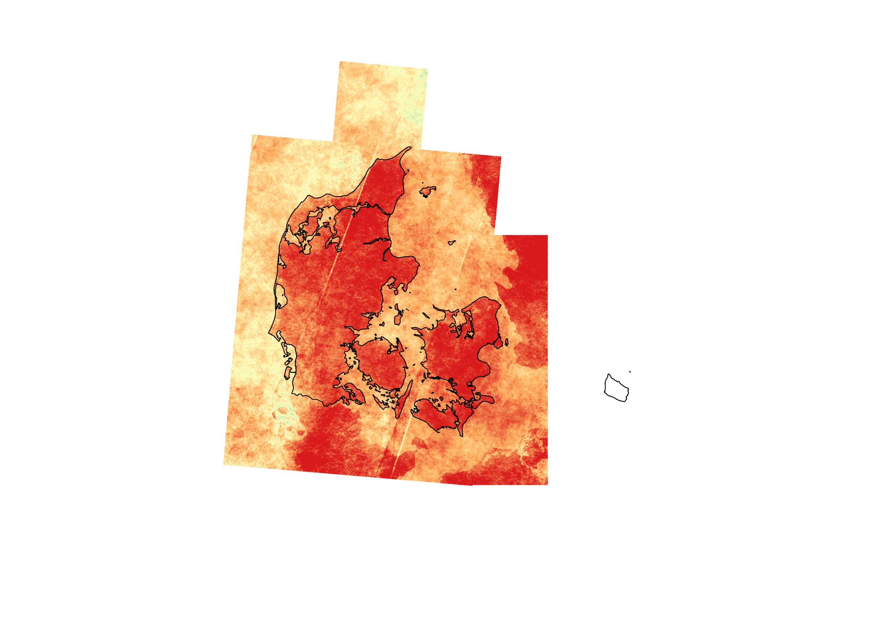

Figure : Cloud map on Denmark using s2cloudless algorithm (blue = 0%, red = 100%)

# Clouds

Automatic cloud detection is a common problem in earth observation and a key issue for processing and analysing time series. We will discuss the pros and cons of a few existing solutions in order to choose one to be used for data selection in the deep learning algorithms.

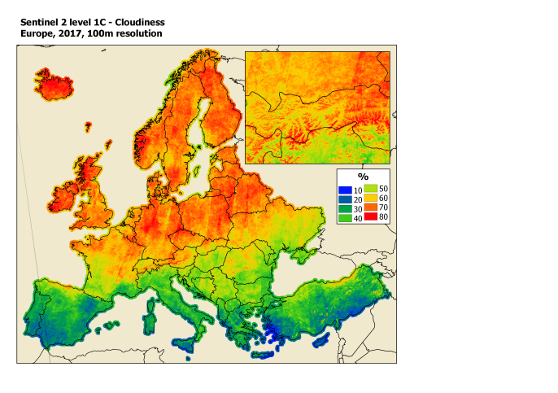

Figure 11 : Cloudiness in Europe produced by GeoVille

The cloud masks studded are the next ones:

* Level 1C cloud masks
* MAJA/MACCS
* Lei-it-snow
* FMASK
* L2A masks – Sen2Cor
* S2cloudless

The first analysis is done on Austria images. A comparison is provided in section 4.7.

One tile (T32TNS at the date 2017-04-07) is manually labelled to precisely measure the quality of those masks (see section 4.7) and visualize the different results. This reference is shown in next figure.

This image was chosen for its different type of clouds in the same picture and the presence of urban structure, mountain and snow. We can consider that a good algorithm for this tile will also work great for other input from the dataset.

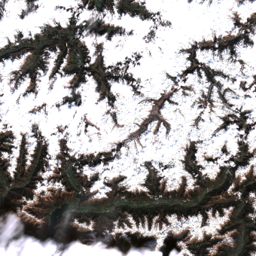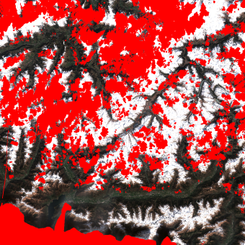



Figure 12 : Manually labelled tile (red = clouds)

## Level 1C cloud mask

Downloaded Sentinel-2 level 1C data contain a cloud mask. Next images show the L1C cloud mask for two mountain scenes in Austria.

Scene 1 is used to compare all the algorithms.

Scene 2 is a particular “worse/difficult case “. It is the same tile than Scene 1 but during winter at the date 2016-01-03.

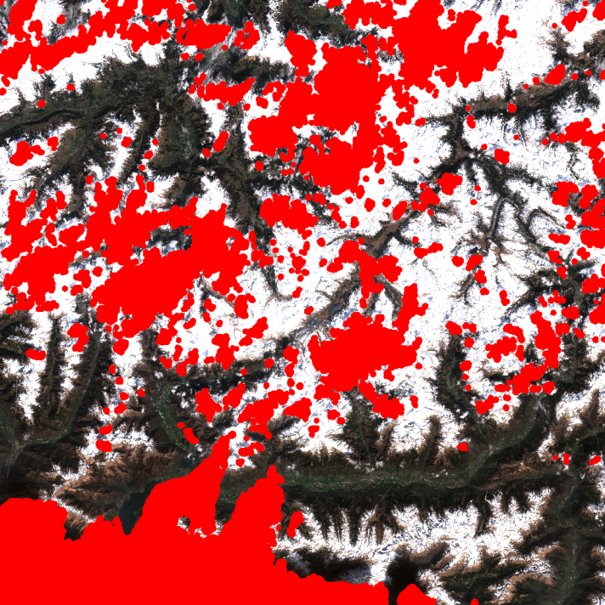

Figure 13 : L1C cloud mask on Scene1 (red = clouds)



**Figure 14 : Scene 2**

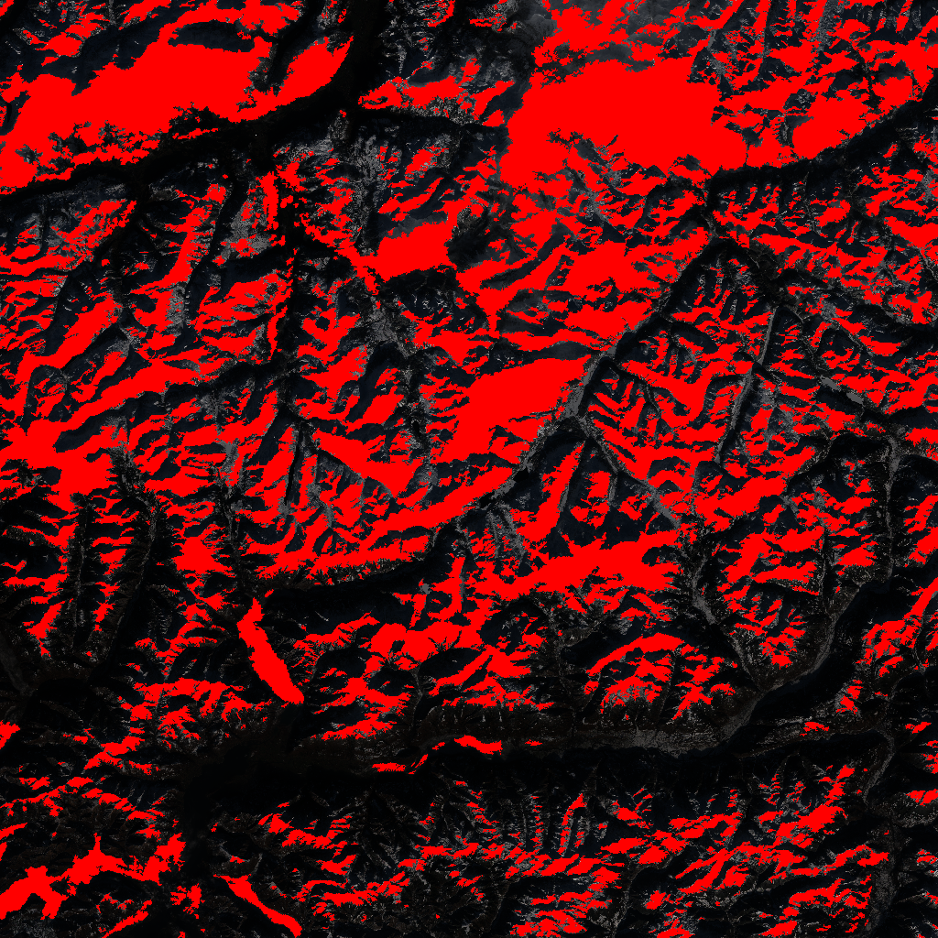

Figure 15 : L1C cloud mask on Scene 2 (red = clouds)

As seen on the previous examples this L1C mask tends to miss some clouds and classify snow as clouds.

For the target products of this project, these classifications errors are not important since the snowy pixels will be useless for crop classification or other agricultural products estimation.

Nevertheless, we need to make sure that the algorithm eliminates all the clouds from the dataset, in order to use it for machine learning and data analysis.

The L1C cloud masks are not efficient enough and have visually too many false positive (as seen in the winter acquisition). We need to pick another one.

## MAJA/MACCS

MAJA tool (<https://logiciels.cnes.fr/en/content/maja>) produces level 2A data from level 1C data. It was developed in collaboration between CNES/CESBIO and DLR on the basis of MACCS and Sen2Cor tools.

It belongs to the multi-temporal methods and visually gives good results in most cases. However, it is not easy to use and very expensive to run.

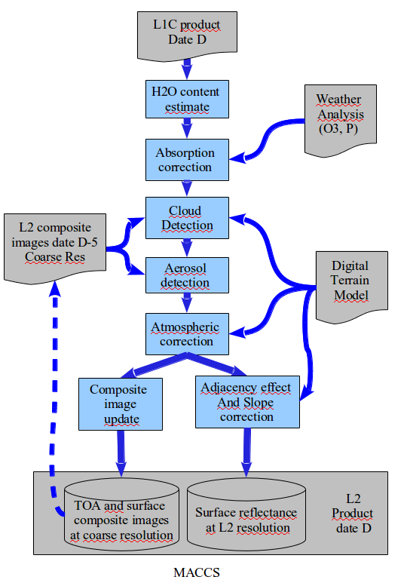

Figure 16 : MACCS diagram

The MAJA masks are only available through the THEIA website from end 2017 and they do not seem to plan to process old images any time soon. We want to consider 2016 data to train our models so we cannot use those masks by the moment.

## Let-it-snow

This algorithm developed by CESBIO detects both clouds and snow but, requires Level 2A data from the MAJA algorithm. Since we cannot compute nor download any level 2A data from the MAJA algorithm for the selected period, we will not use it.

## FMASK

FMASK (http://pythonfmask.org/en/latest/) algorithm is based on the papers:

* Zhu, Z. and Woodcock, C.E. (2012). Object-based cloud and shadow detection in Landsat imagery Remote Sensing of Environment 118 (2012) 83-94,
* Zhu, Z., Wang, S. and Woodcock, C.E. (2015). Improvement and expansion of the Fmask algorithm: cloud, cloud shadow, and snow detection for Landsats 4-7, 8, and Sentinel 2 images Remote Sensing od Environment 159 (2015) 269-277

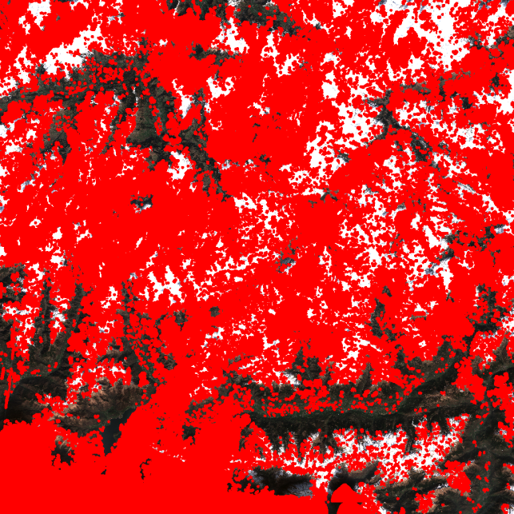

Figure 17 : Result on scene 1 (red = clouds)

Just as the level 1C cloud mask, this algorithm visually gives too many false positive and after a few tests this algorithm is eliminated.

## L2A MAsks - Sen2Cor

Sen2Cor is a processor for Sentinel-2 Level 2A product generation and formatting; it performs the atmospheric-, terrain and cirrus correction of Top-Of- Atmosphere Level 1C input data. Sen2Cor creates Bottom-Of-Atmosphere, optionally terrain- and cirrus corrected reflectance images; additional, Aerosol Optical Thickness-, Water Vapor-, Scene Classification Maps and Quality Indicators for cloud and snow probabilities. Its output product format is equivalent to the Level 1C User Product: JPEG 2000 images, three different resolutions, 60, 20 and 10 m. Sen2Cor is an algorithm provided by ESA in the STEP platform (Science Toolbox Exploitation Platform, http://step.esa.int/main/third-party-plugins-2/sen2cor/). It provides good atmospheric correction and is widely used. In particular, Sen2Cor is used to deliver official Sentinel-2 L2A products.

The advantage of this solution is that it produces atmospheric correction, a cloud mask and a snow mask at the same time.

A comparison of MAJA and Sen2Core cloud masks against a hand made reference is also provided here: <http://www.cesbio.ups-tlse.fr/multitemp/?tag=sen2cor>

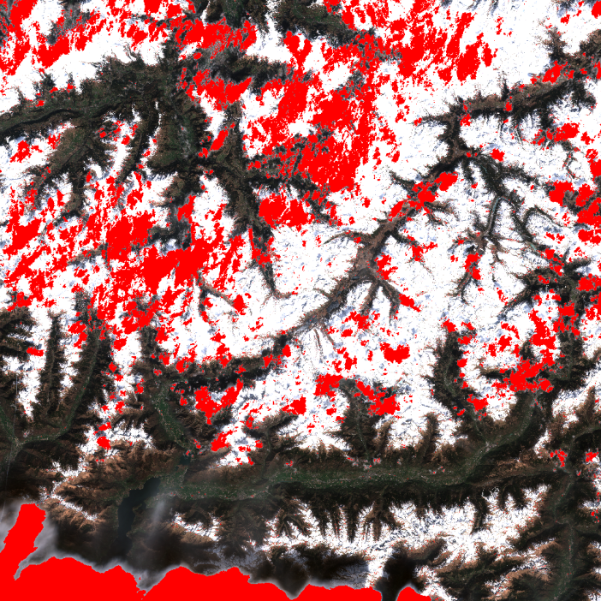

Figure 18: Sen2Cor cloud mask on scene 1 (red = clouds)

## S2cloudless

This algorithm, made by Synergise, seems to produce the best results in most of our tests:

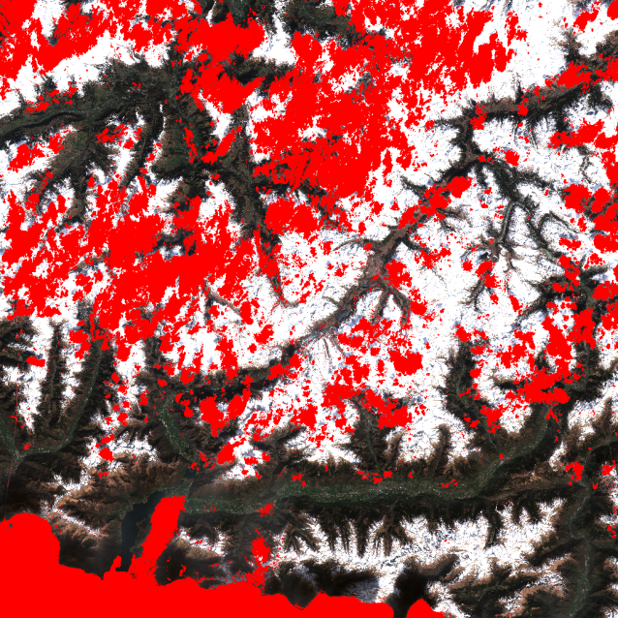

Figure 19 : s2cloudless cloud mask

On our test machine, it takes between 5 and 10 minutes to compute a cloud mask. It visually seems to produce the lowest false positive rate (it doesn’t classify snow or building as cloud as much as other algorithms seen here) of the algorithms tested here and picks up both, thin and thick clouds.

## Performance comparison

We only have one labeled tile so we cannot statistically generalize from the following results but it can help to choose one algorithm over another. We chose that picture for the presence of urban structure, mountain and snow so it will give interesting results.

We get the following results:

|  |  |  |  |  |
| --- | --- | --- | --- | --- |
|  | S2Cloudless | Sen2Cor | L1C | FMASK |
| True Positive | 0.279 | 0.186 | 0.256 | **0.304** |
| True Negative | 0.639 | **0.645** | 0.576 | 0.193 |
| False Positive | 0.017 | **0.007** | 0.069 | 0.152 |
| False Negative | 0.065 | 0.162 | 0.099 | **0.051** |
| Precision | 0.943 | **0.965** | 0.788 | 0.667 |
| Recall | 0.812 | 0.535 | 0.722 | **0.858** |

Figure 20 : Measures on the cloud masks tested

For the best quality of mask, s2cloudless seems to be the better option.

# Snow detection

As far as snowy regions can be useless for our time series analysis or training steps in machine learning, we have tested some snow detection algorithms in order to obtain clean regions, cloud and snow free.

Two solutions are discussed here to avoid the presence of mislabeled snow in the dataset: A manual selection of the period usable (remove winter) or an automatic detection using existing algorithms.

**Manual selection:** If no snow mask works for us we can manually select the period for each tile without any snow. We could then cross this period with crop seasons to only use the appropriate images.

However, this solution potentially removes a lot of areas that could otherwise be used for our dataset as it concerns the whole tile:

|  |  |  |  |  |  |  |
| --- | --- | --- | --- | --- | --- | --- |
| **ID Tiles** | **Winter Season** | | | | | |
| **2015-2016** | | **2016-2017** | | **2017-2018** | |
| **Start** | **End (included)** | **Start** | **End** | **Start** | **End** |
| 32TNS | 2016-01-03 | 2016-08-30 | 2016-10-29 | 2017-08-05 | 2017-11-03 | 2017-12-28 |
|
| 32TNT | 2016-01-03 | 2016-05-22 | 2016-11-08 | 2017-07-06 | 2017-10-24 | 2017-12-28 |
|
| 32TPS | 2016-01-03 | 2016-09-06 | 2016-09-16 | 2017-08-22 | 2017-09-01 | 2017-12-28 |
|
| 32TPT | 2016-01-03 | 2016-09-26 | 2016-10-06 | 2017-07-18 | 2017-09-01 | 2017-12-28 |
|
|

Figure 21 : Example of winter season for some tiles

**Algorithms:** Two of the previously mentioned algorithms also produce snow masks: Sen2Cor and Let-It-Snow. Both algorithms seem to produce good results and used with a cloud detector could help remove unwanted region in the dataset.

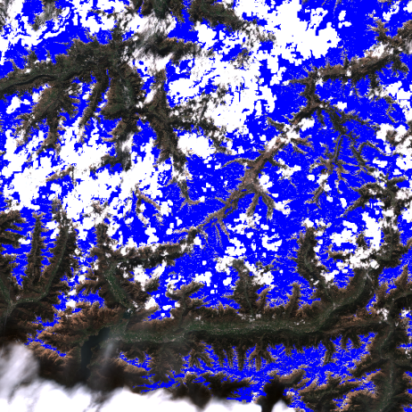

Figure 22 : Let-it-snow snow mask on scene 1 (blue = snow)

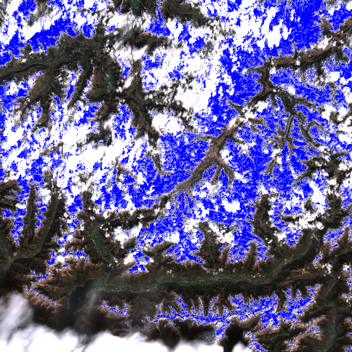

Figure 23 : Sen2Cor snow mask (blue = snow)

# L2A Correction

## MAJA / MACCS

As said before the MAJA tool produces level 2A images but is really expensive to run and only a few tiles are available for free. Here is an example of the output:

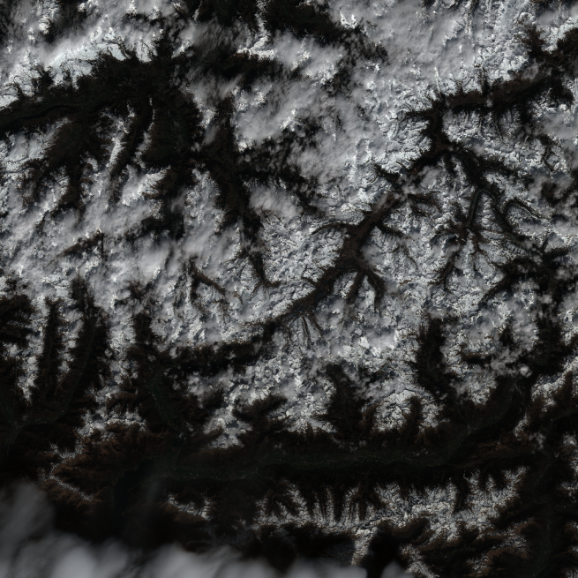

Figure 24 : Original L1C data (scene 1)

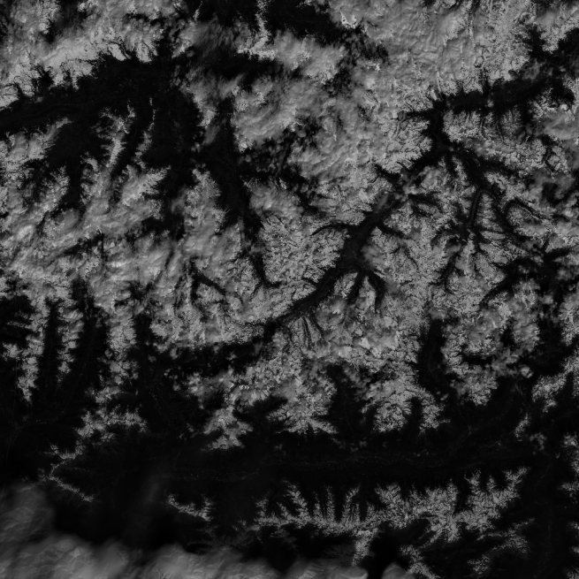

Figure 25 : MAJA L2A data produced

## Sen2COR

Sen2Cor is the most commonly used algorithm for atmospheric correction and is relatively fast to compute. It is the official processor used by ESA. This algorithm will be used for this project.

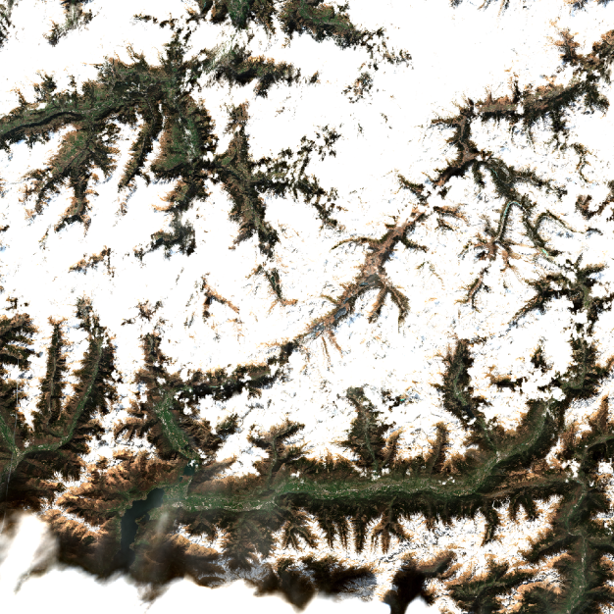

Figure 26 : Sen2Cor L2A Data produced

# LPIS analYsis

This section provides an analysis of the usability of the Sentinel-2 dataset, jointly with the LPIS information, as a training database for machine learning algorithm.

LPIS data don’t cover the entire surface covered by the Sentinel-2 acquisitions. We want to estimate the ratio of usable data in the dataset.

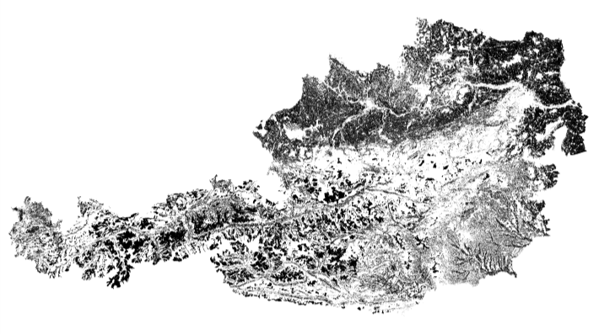

Figure 27 All LPIS data in Austria

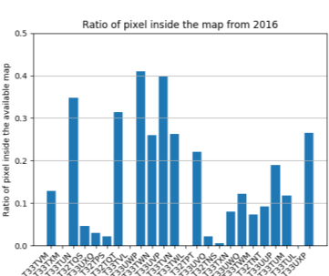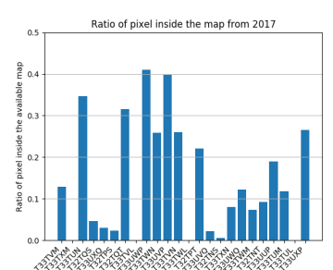

Figure 28 : Ratio of pixel inside the Austrian LPIS data (any crop) in a few tiles

It the previous figures, we can see that a lot of the pixels that are in the dataset don’t have corresponding LPIS data. They don’t correspond to cultivated areas. For crop areas characterization, only about a quarter of the pixels will be usable in Austria. Moreover, clouds must also be removed.

**Percentage of valid pixels**

The original Austrian LPIS file contains 201 categories that can be classified into a more general one (proposed by Geoville):

* We first organise the data into the following class: **cereals, grass, legumes, maize, mixed_plants, orchard, other_plants, potato, production_under_protection, pseudo_cereals, vegetable, vineyard and unclassified.** (See the non-EO data description: WP/WP2/Slovenian_lpis_sifrant.xls file))
* And then compute for each tile the ratio of each class and the ratio of data that are in fact covered by clouds.

At the end we can conclude from those results tha, only about 10% of the pixels that are in the dataset will in fact be used for the training.

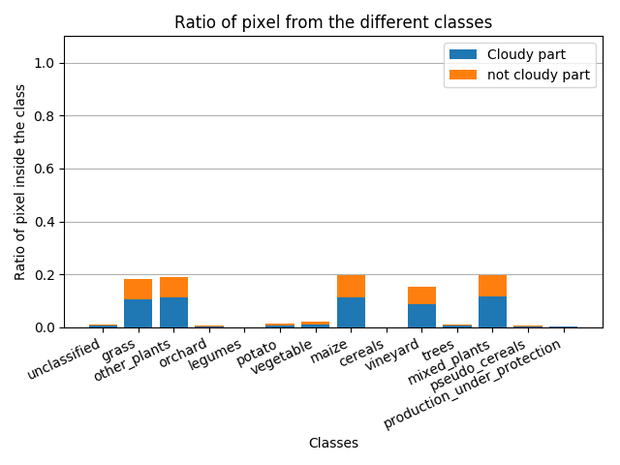

Figure 29 : Example on the tile T33TXN

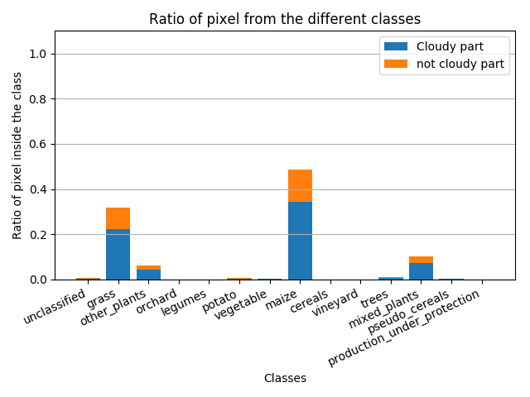

Figure 30 : Example on the tile T33UUP

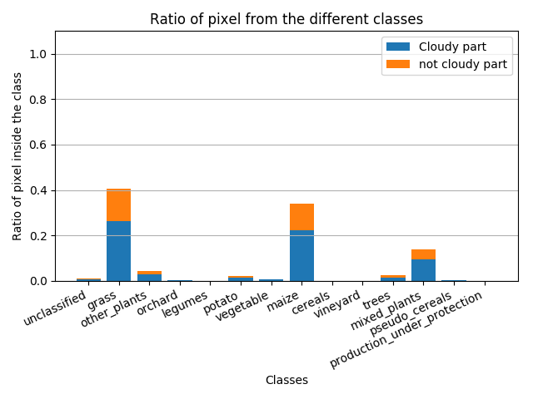

Figure 31 : Example on the tile T33UVP

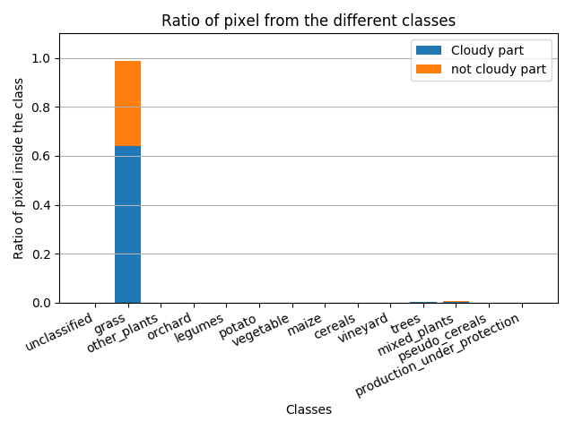

Figure 32: Example on the tile T33TUN